Full paper - Title

Name1 Surname1, Name2 Surname2 and Name3 Surname3 (subtitle)

Affiliation University, Faculty, Department, Institute
Address, City, Postal Code, Country
E-mail

Keywords: keyword, keyword, maximum of 5 keywords (text)

Introduction Example (caption 1)
Text text text text text text text text text text text text text text text text text text text text text text text text text text text text text text text text text text text text text text text text text text text text text text text text text [1]. Text text text text text text text text text text text text text text text text text text text.
Text text text text text text text text text text text text text text text text text text text text text text text text [2]. Text text text text text text text text text text text text by Ho & Sommerfeld [1].Text text text text text text text text text text text text text text text text text text text.

Chapter (caption 1)
Text text text text text text text text text text text text text text text text text text text text text text text text text text text text text text text text text text text text text text text text text text text text text text text text text text text text text text text text text text text text text text text text text text text text text text text text text text text text text text text text text text text text text text text text text text text text text text text text text text text text text text text text text text text text.

Chapter-Example (caption 2)
Text text text text text text text text text text text text text text text text text text text text text text text text text text text text text text text text text text text text text text text text text text text text text text text text text text text text text.
Text text text text text text text text text text text text text text text text text text text text text text text text text text text text text text text text text text text text text text text text text text text text text text text text text text text text text text text text text text text text.

Chapter-Example (caption 3)
Text text text text text text text text text text text text text text text text text text text text text text text text text text text text text text text text text text text text text text text text text text text text text text text text text text text text text text text text text text text text text text text text text text text text text text text text text text text text.
Figure 1: Example text text text text text text (graphic)
Text text text text text text text text text text text text text text text text text text text text text text text text text text text text text text text text text text text text text text text text text text text text text text text text text text text text text.

Chapter 2 (caption 1)
Text text text text text text text text text text text text text text text text text text text text text text text text text text text text text text text text text text text text text text text text text text text text text text text text text text text text text text text text text text text text text text text text text text text text text text text text text text text text text text text text text text text text text text text text text text text text text text text text text text text text text text text text text text text text text text text text text text text text text text text text text text text text text text text text text text text text text text text text
Table 1. Calibration example (table)
Number | Values | Values | Values | Values
1 | 2.45 | 356.3 | 4.0 | 4.567
2 | 3.675 | 48.5 | 3.3 | 5.452
3 | 4.543 | 389.4 | 2.2 | 7.123
4 | 5.98 | 590.5 | 5.4 | 3.896

Chapter 3 (caption 1)
Text text text text text text text text text text text text text text text text text text text text text text text text text text text text text text text text text text text text text text text text text text text text text text text text text text text text text text text text text text text text text text text text text.

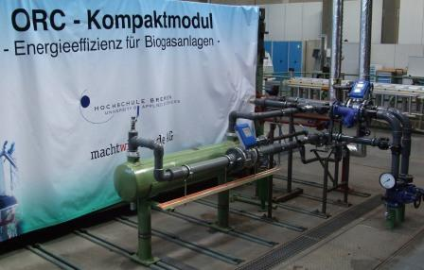
Figure 2: Example text text text text text text text text. (grafic)
Text text text text text text text text text text text text text text text text text text text text text text text text text text text text text text text text text text text text text text text text text text text text text text text text text text text text text text text text text text text text text text text text text text text text text text text text text text text text text text text text text text text text text text text text text text text text text text text text text text text text text text text text text text text text text text text text text text.

Conclusions (caption 1)
Text text text text text text text text text text text text text text text text text text text text text text text text text text text text text text text text text text text text text text text text text text text text text text text text text text text text text text text text text text text text text text text text text text text text text text text text text text text text text text text text text text text text text text text text text text text text text text text text text text text text text text text text text text text text text text text text text text
Text text text text text text text text text text text text text text text text text text text text text text text text text text text text text text text text text text text text text text text text text text text text text text text text text text text text text text text text text text text text text text text text text text text text text text text text text text text text text text text text text text text text text text text text text text text text text text text text text text text text text text text text text text text text text text text text text text text text text text text text text text text.

References (caption 1)
- Ho, C.A. & Sommerfeld, M.: Title. Journal, Vol. xx, xxxx-xxxx (enumeration, left)
- Sommerfeld, M. : Title. Journal, Vol. xx, xxxx-xxxx (enumeration, left)

